 | Monday, October 16, 2017
12:00 PM to 4:00 PM | NESMEA Registration – 3rd Floor Foyer
6:00 PM to 10:00 PM | Trade Show Vendor Set Up – 3rd Floor Foyer
1:00 PM to 5:00 PM | Closed Door Meeting (State/FHWA Invitees ONLY) – Ethan Allen Room
 | Tuesday, October 17, 2017
7:00 AM to 5:00 PM | NESMEA Registration and Trade Show – 3rd Floor Foyer
7:00 AM to 8:00 AM | Continental Breakfast – Hilton Grand Ballroom West
8:00 AM to 8:10 AM | Welcome to Connecticut – Ballroom East & Center  NESMEA Meeting Chair – Robert Lauzon, Ph.D., P.E., Principal Engineer, Materials Testing, ConnDOT
8:10 AM to 8:25 AM | Opening Remarks – Ballroom East & Center James Redeker, Commissioner, ConnDOT
Session A Construction
8:25 AM to 8:30 AM | Moderator: Jonathan Boardman, P.E., Supervising Engineer, Materials Testing, ConnDOT
8:30 AM to 9:00 AM | Q-Bridge Project Highlights Domenic LaRosa, P.E., District Engineer, District 3, ConnDOT
9:00 AM to 9:30 AM | eConstruction Efforts in Connecticut Christopher Angelotti, P.E., Principal Engineer, Office of Construction, ConnDOT
9:30 AM to 10:00 AM | Architecture Engineering & Construction (AEC) at ConnDOT William Pratt, P.E., Principal Engineer, Facilities and Transit, ConnDOT
10:00 AM to 10:25 AM | Break - Trade Show (3rd Floor Foyer) and Mark Twain Room
Session B Steel/Welding/Coatings
10:25 AM to 10:30 AM | Moderator: David Parillo, P.E., Engineer 3, Materials Testing, ConnDOT
10:30 AM to 11:00 AM | Coatings for Concrete  Kenneth Trimber, President, KTA-Tator, Inc.
11:00 AM to 11:30 AM | Forensics – The Art and Science of Why Stuff Breaks Raymond Monson, P.E., Senior Engineer, Pennoni Associates, Inc.
11:30 AM to 12:00 PM | Performance Engineered Concrete – It’s Time for a Change Michael F. Praul, M.C.E., P.E., Senior Concrete Engineer, FHWA’s Office of Asset Management, Pavements, and Construction and the Manager of the FHWA Mobile Concrete Trailer Program
12:00 PM to 1:00 PM | Lunch Buffet – Hilton Grand Ballroom West
Session C Aggregates
1:00 PM to 1:05 PM | Moderator: Charles Gardon, Engineer 3, Materials Testing, ConnDOT
1:05 PM to 1:45 PM | Alkali Silica Reaction of Aggregates in Massachusetts Richard Mulcahy, Civil Engineer, Research and Materials, MassDOT;  John Grieco, Director, Research and Materials, MassDOT
1:45 PM to 2:30 PM | Aggregates Containing Pyrrhotite James Mahoney, Executive Director, Connecticut Transportation Institute & CAP Lab, University of Connecticut
2:30 PM to 3:00 PM | Break - Trade Show (3rd Floor Foyer) and Mark Twain Room
Session D Concrete
3:00 PM to 3:05 PM | Moderator: Daniel Guzzo, Engineer 3, Materials Testing, ConnDOT
3:05 PM to 3:35 PM | Project Highlights: CTFastrak – Precast Pavement TBD Steve Norton, Engineer 3, Pavement Management, ConnDOT
3:35 PM to 4:05 PM | Sharing Inspection Resources NETC Eshan Dave, Ph.D., Assistant Professor, University of New Hampshire
4:05 PM to 4:35 PM | High Performance Concrete Steel Beam End Repairs Arash Zaghi, Ph.D, P.E., S.E., Assistant Professor, University of Connecticut
5:30 PM to 6:30 PM | Reception – Trade Show Area (3rd Floor Foyer)
7:00 PM | Dinner – Hilton Grand Ballroom West

 | Wednesday, October 18, 2017
7:00 AM to 5:00 PM | Registration for NESMEA and NEAUPG and Trade Show – 3rd Floor Foyer
7:00 AM to 8:00 AM | Continental Breakfast – Hilton Grand Ballroom West
8:00 AM to 8:10 AM | Welcome – Ballroom East & Center NESMEA Meeting Chair – Robert Lauzon, Ph.D., P.E., Principal Engineer, Materials Testing, ConnDOT
Session E HMA
8:10 AM to 8:15 AM | Moderator: David Howley, Engineer 3, Materials Testing, ConnDOT
8:15 AM to 8:45 AM | Comparison of Different Laboratory Aging Methods for Performance Evaluations Reyhaneh Rahbar-Rastegar, Ph.D., Research Engineer, Purdue University
8:45 AM to 9:15 AM | Non-Destructive Technologies to Detect Asphalt Pavement Delamination and Moisture Damage Michael Heitzman, Ph.D., P.E., Assistant Director/Senior Researcher, National Center for Asphalt Technology
9:15 AM to 10:00 AM | Use of Field Spectroscopy Technology for Evaluating Construction Materials  Maria Chrysochoou, Ph.D., Associate Professor, University of Connecticut; Terry Arnold, Senior Research Chemist, FHWA Turner Fairbank Highway Research Center
10:00 AM to 10:25 AM | Break – Trade Show (3rd Floor Foyer) and Mark Twain Room
Session F HMA
10:25 AM to 10.30 AM | Moderator: Eliana Carlson, M.S., P.E., Supervising Engineer, Materials Testing, ConnDOT
10:30 AM to 11:00 AM | Balanced Asphalt Mix Design – A Formula for Success Shane Buchanan, Ph.D., P.E., Asphalt Performance Manager, Oldcastle Materials
11:00 AM to 11:30 AM | The AMPT: Advances in Performance-Related Specifications and Performance Engineered Mix Design David Mensching, Ph.D., Pavement Materials Engineer, FHWA
11:30 AM to 12:00 PM | Seeking Improved Pavement Performance Through Increased Density  John Haddock, Ph.D., P.E., Professor of Civil Engineering at Purdue University and Director of Indiana Local Technical Assistance Program
12:00 PM to 12:05 PM | 2018 NESMEA – Welcome to New Jersey Paul Hanczaryk, M.S., Manager, Bureau of Materials, NJDOT
12:05 PM | Adjourn Meeting – NESMEA 2017

NESMEA Sponsors
AASHTO re:source * | KTA-Tator, Inc.
Advance Testing Company, Inc. * | King Shotcrete Solutions *
All States Materials Group * | Myers Construction Materials Testing Equip. *
American Galvanizers Association * | NETTCP *
CMEC Inc. * | Norlite, LLC *
Concrete Pipe Association of NJ * | Northeast Solite Corporation *
Controls Group USA, Inc. * | Pennoni *
CTS Cement Manufacturing Corp. * | Pine Instruments *
EJ USA, Inc. * | Rinker Materials – Stormceptor *
FHWA * | Terracon Consultants, Inc. *
Greenman-Pedersen, Inc. * | Unique Paving Materials Corp. *
HRV Conformance Verification Associates, Inc. | United Concrete Products, Inc. *
InfraTest USA * | Uretek USA *
Iterchimica * | Zydex, Inc.
The NESMEA sponsors with an asterisk have a Vendor Table in the Trade Fair Area.

2017 NESMEA State Members

Connecticut - Robert Lauzon
Delaware - Jennifer Pinkerton
Maine - Richard Bradbury
Massachusetts - John Grieco
New Hampshire - Denis Boisvert
New Jersey - Paul Hanczaryk
New York - John Rondinaro
Pennsylvania - Robert Horwhat
Rhode Island - Jose Lima
Vermont - Mladen Gagulic

NESMEA Since 1923
1923-57 Albert V. Pratt (Founder) MA | 1979 Francis W. Holden MA | 1995 Alan D. Rawson NH | 2011 Mark E. Felag RI
1958-60 Paul S. Otis NH | 1980 Louis P. Perricone CT | 1996 Robert F. Cauley VT | 2012 Timothy Ramirez PA
1961-62 Harry H. McLean NY | 1981 E. Robert Wokoun NJ | 1997 Clement W. Fung MA | 2013 Alan D. Rawson NH
1963-64 Joseph C. Reed NJ | 1982 James J. Murphy NY | 1998 Keith R. Lane CT | 2014 John E. Grieco MA
1965-66 Anthony R. Healy RI | 1983 Frederick M. Boyce ME | 1999 Eileen C. Sheehy NJ | 2015 Mladen Gagulic VT
1967-68 John J. Lyons MA | 1984 Robert L. Fruggiero RI | 2000 Bruce A. Yeaton ME | 2016 Jennifer Pinkerton DE
1969 Richard I. Rowell VT | 1985 Ronald J. Cominsky PA | 2001 Robert L. Sack NY | 2017 Robert Lauzon CT
1970 David Pere Chapel PR | 1986 Philip E. McIntyre NH | 2002 Mark E. Felag RI
1971 T. William Cavanaugh CT | 1987 J. R. Phalen VT | 2003 Gerald J. Malasheskie PA
1972 Chester J. Andres NJ | 1988 Gino J. Bastanza MA | 2004 Alan D. Rawson NH
1973 Harry H. McLean NY | 1989 Keith R. Lane CT | 2005 Donald H. Lathrop VT
1974 Frederick M. Boyce ME | 1990 Joseph R. Smith NJ | 2006 James Pappas DE
1975 Robert L. Fruggiero RI | 1991 Theodore H. Karasopoulos ME | 2007 Keith R. Lane CT
1976 Leo D. Sandvig PA | 1992 Wayne J. Brule NY | 2008 Eileen C. Sheehy NJ
1977 Philip E. McIntyre NH | 1993 Mark E. Felag RI | 2009 Bruce A. Yeaton ME
1978 Roy F. Nicholson VT | 1994 Charles A. Kline PA | 2010 Don Streeter NY

For additional information, go to the NESMEA Website at www.nesmea.uconn.edu.

NESMEA 2017
Northeastern States Materials Engineers’ Association

93rd Annual Meeting
October 17 – 18, 2017
Hilton Hartford Hotel – 315 Trumbull Street – Hartford, CT 06103

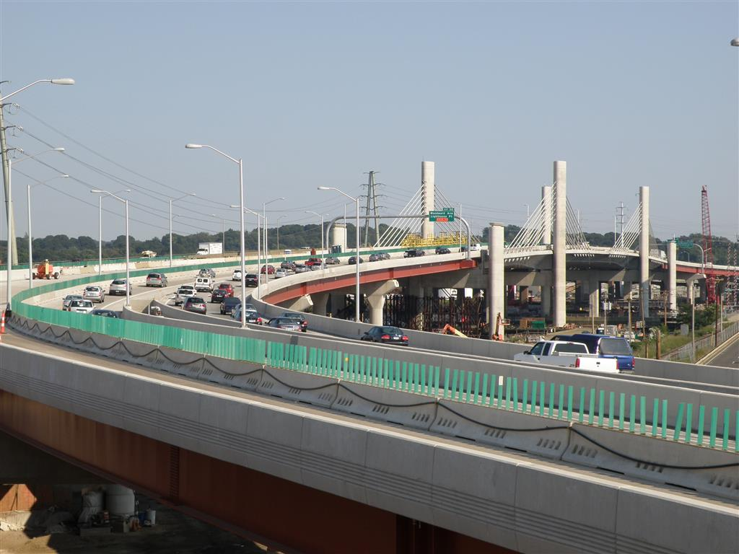
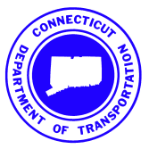
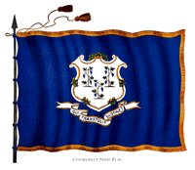
Hosted by the
Connecticut Department of Transportation

